Snapshot Use Cases

Version 1.00

Revision History
Date | Author | Description of change
13/12/2011 | Greg Payne | First draft

Use Case: Schedule SMS

Id: UC- 001

Description
Stock managers or product owners wish to schedule SMS requests for stock count. The user sets up a schedule of when a message is to be triggered in the system.

Level: High Level
High level summary of the functionality required to schedule SMS requests

Primary Actor
Product Owner

Supporting Actors
Stock Manager

Stakeholders and Interests
Customer – to ensure that a request is made on a regular basis.
Stock Manager – to ensure that an accurate and timely stock count is maintained in the system

Pre-Conditions
A profile for the project has been established at the Country, Region and District level.
[OA] – What means a profile for the project? [GP] I mean the project has been setup
Outposts have been setup to receive SMS messages
[OA] – Is it enough to select the contact method at the Outpost level (a mobile number will be selected as preferred contact method)? [GP] Yes

Post Conditions
Messages are scheduled on a regular basis

Success end condition
SMS messages are received on a scheduled basis by Outposts and reminders are set for requests not responded to. User responds to SMS and stock levels are updated on the scheduled basis.

Failure end condition:
Outposts have not received their SMS requests as expected in line with training.

Flow

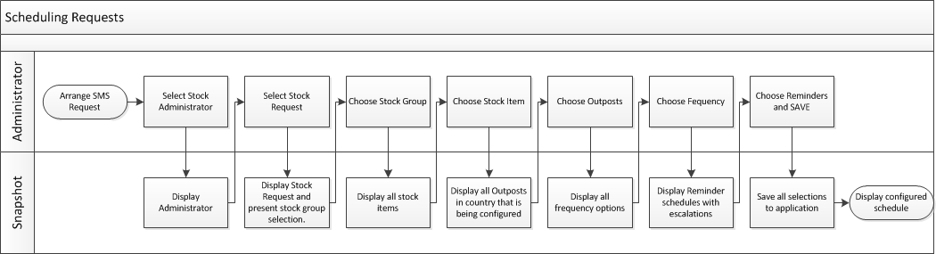

Trigger
A Stock Administrator (Stock Manager, Product Owner) needs to create an SMS request schedule in the application so that automated requests are sent at defined times.

Main Success Scenario
- The Actor accesses Stock Administrator section of the application
- The Actor accesses the Stock Request section within the Administrator
- The Actor is presented with the following fields:
Stock Group
[OA]- Would be possible to select only the stock group, without to select the stock item? [GP] Must select group and that opens items to select. I think the stock group should have drop down and select items from group.
Stock Item
Outposts (Choose from a complete list of registered outposts)
[OA] – Should the actor select more outposts or all outposts in order to send scheduled SMS requests? [GP] Select only Outposts that are required. Scheduling should be done at group level to all outposts in the campaign or program for stock items in the group that are relevant. A stock group can have items added to it but select only those outposts that will be asked about the items in a group that are customer defined.
Frequency
- The Actor chooses a value from each of these fields from a drop down menu
- The Actor selects ‘Reminders’
- The system presents a selection of reminders
- The Actor selects the reminder schedule which consists of default reminders:
1st Reminder 24 hours later
2nd reminder 3 days later
- The system presents a selection of escalation choices:
Alerts
Emails
- The Actor selects escalation method and chooses the email and mobile number of Stock manager for his district.
- The Actor chooses to save the selections he has made.
- The System saves the selections to the database.
- The Use Case ends

Alternates

3a. In Step 3, the stock group or stock item may not be shown in the drop down list
- System will display a search option.
- The Actor has the option to search a stock group, stock item and Outpost.

4a. In step 4, the frequency shall be related to a stock group and stock item and the value selected here will determine what drug is collected from where and on what day.
[OA]- this means that it is mandatory to select a stock group, a stock item and an Outpost? [GP] As above the group selected should open all items in that group and then select items
1. System will prompt for frequency selection payment of the dues
2. The Actor selects from a choice of:
Daily
Weekly - what day of week?,
Twice weekly – what days?,
Monthly – what day?,
Twice monthly – what weeks?)
NB: This selection could be a pop up calendar
3. The Actor confirms his selection
4. Use Case resumes on step 4.

Variations
None

Assumptions
- All Outposts for a country will be stored in the system
- All variations of time will be stored in the system
[OA] – what represent variations of time? [GP] This means weekly, monthly or whatever is selected. Ignore this as explained above.

Special Requirements
None

Issues

